Ids – intrusion detection system



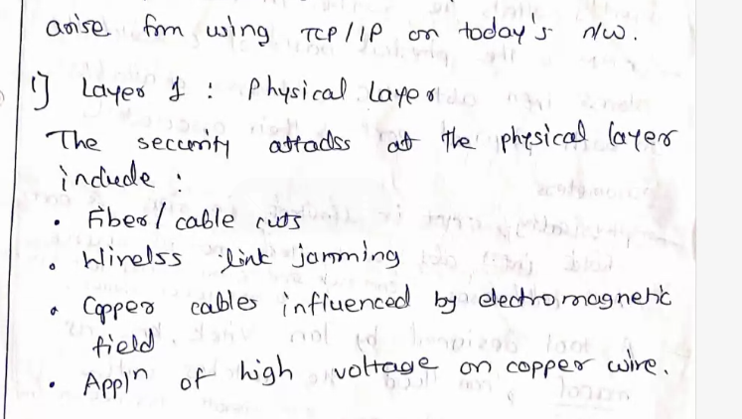

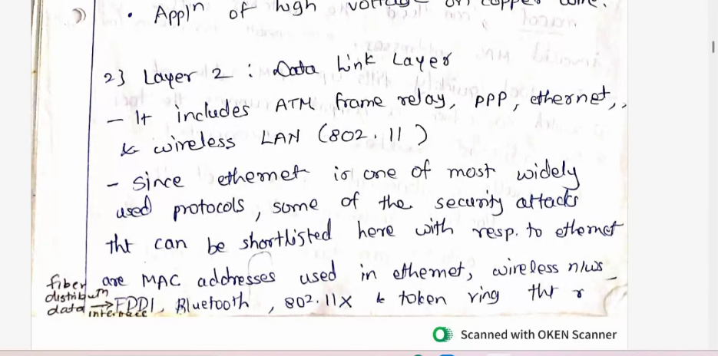

To develop wireless lan in the college folloe ieee 802.11

Wireless network forming

-router

-wireless lan card in the machine

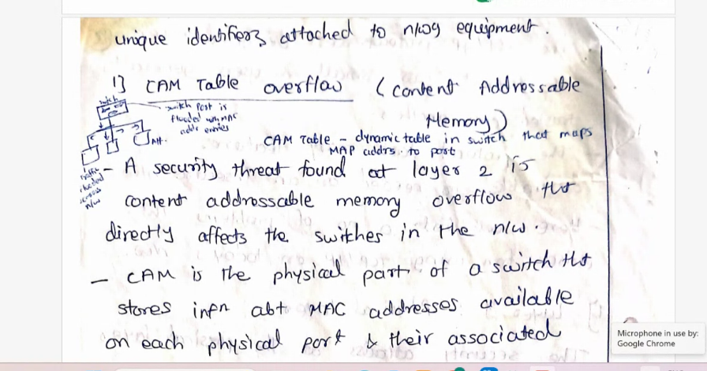

Cam table has two columns

-mac address

-port

